ICAR-CENTRAL INLAND FISHERIES RESEARCH INSTITUTE
(INDIAN COUNCIL OF AGRICULTURAL RESEARCH)
BARRACKPORE: KOLKATA - 700 120
Phone No. (033) 2592 1190/1191
E-mail: cifri@vsnl.com, Website: cifri.res.in

F. No. Swachh Bharat/Adm.II/ | Dated 28th April, 2018

Action taken report on Swachh Bharat Abhiyan for the month of April, 2018:-

Activity at ICAR-CIFRI, Bangalore:-
As a part of Swachh Bharat Abhiyan, cleaning activities were taken up in Research Centre, ICAR-CIFRI, Bangalore on 24th April, 2018. All scientists and staff of the centre actively participated in the cleaning process. Office premises and garden area were cleaned. Unwanted weeds and dried leaves were removed from the lawn.
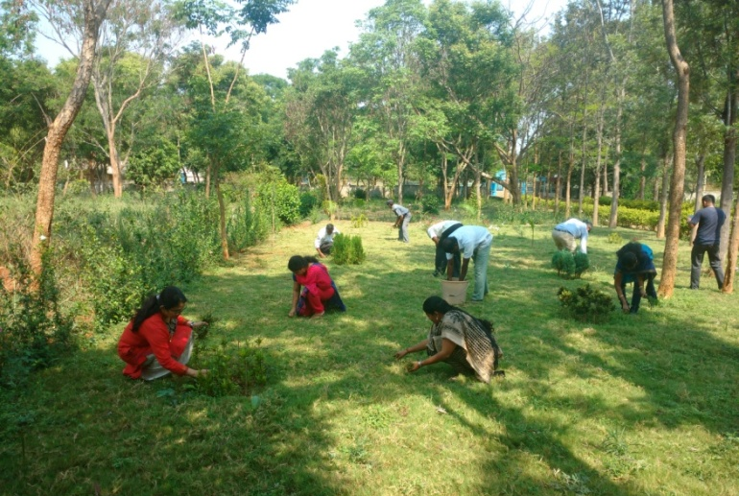

Cleaning activities in garden, Research centre, ICAR-CIFRI
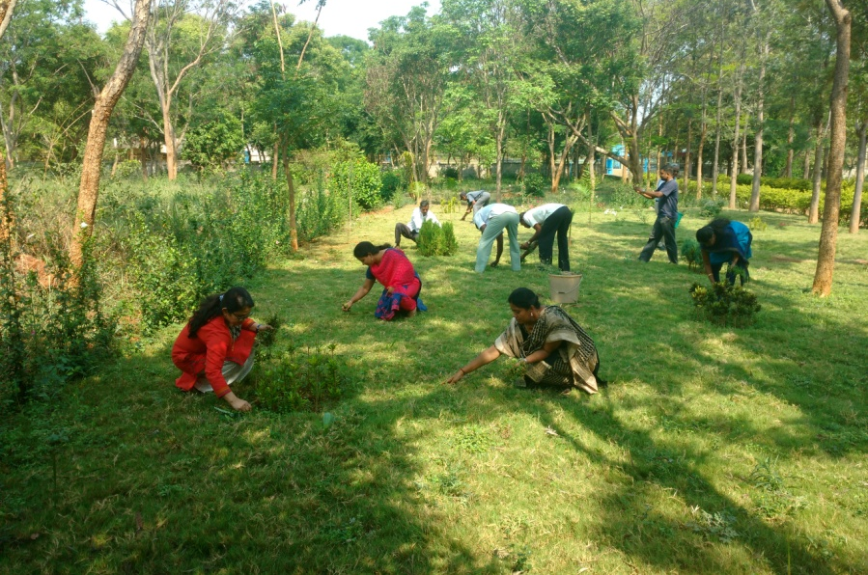
Cleaning activities in garden, Research centre, ICAR-CIFRI
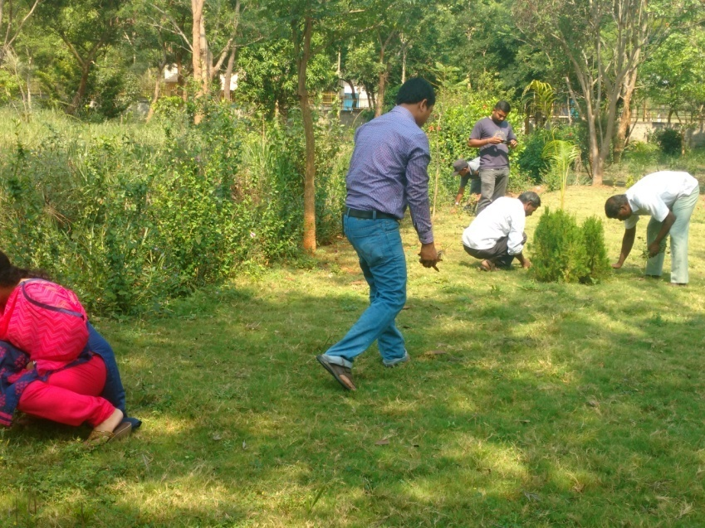
Cleaning activities in garden, Research centre, ICAR-CIFRI

Activity at ICAR-CIFRI, Kolkata:-
At CIFRI Kolkata Centre, CGO Complex, Salt Lake Kolkata, all the regular and contractual staff have routinely engaged a part of their duty hours for keeping the working ambience clean. As part of our activities for Swaachhta in the centre, some glimpses of our activities are attached herewith.

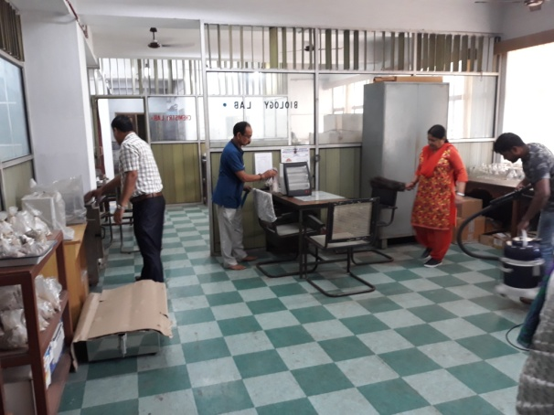 | 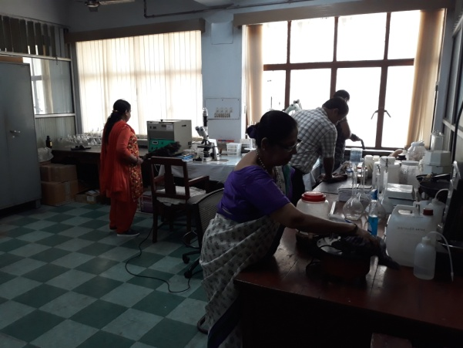
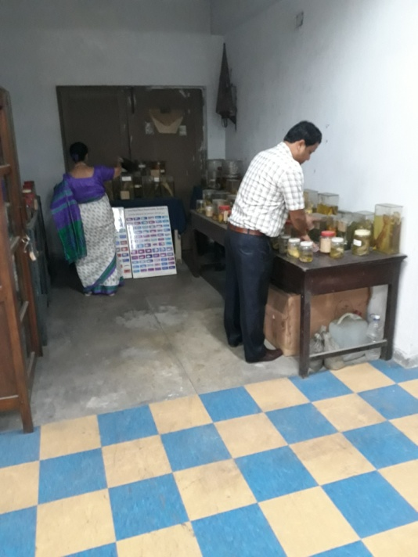 | 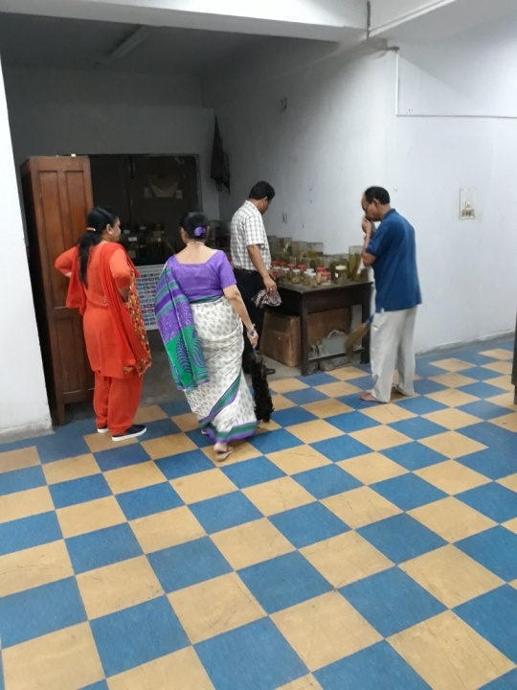
Photos above:- The Staff members of ICAR-CIFRI, Kolkata are cleaning Office premises.
Activity at ICAR-CIFRI, Vadodara:-
Swachh Bharat programme for the month of April was performed on 4th April, 2018. All staff of the centre including scientific, technical, administrative and supporting participated in the programme. This time all rooms, garden and parking area of office were cleaned. During this programme, especially Library of the centre is arranged by cleaning all the racks and almirahas. All the staff actively involved in the programme.

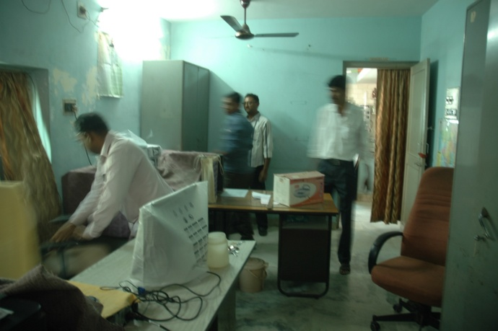
Cleaning Technical Room

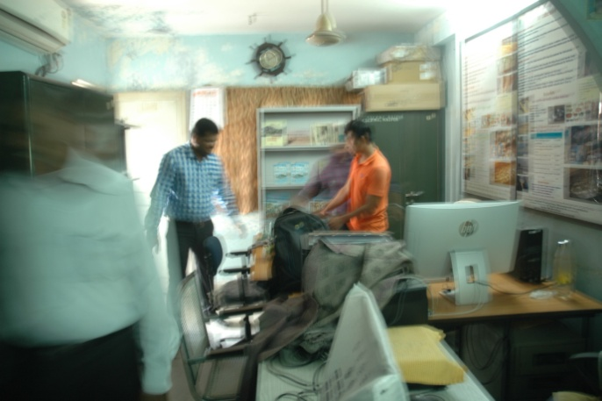
Cleaning Scientist’s Room

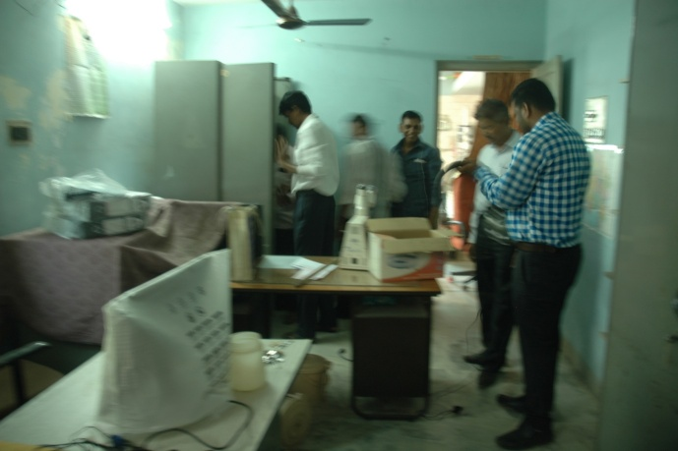
Cleaning Technical Room

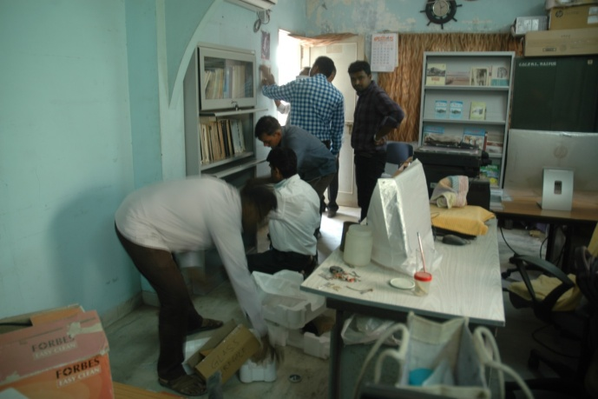
Cleaning Library

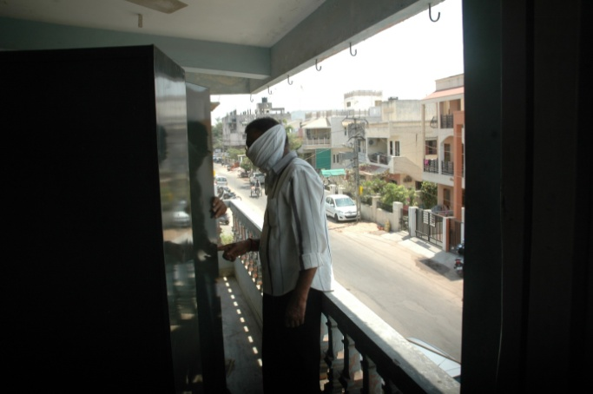
Cleaning Veranda

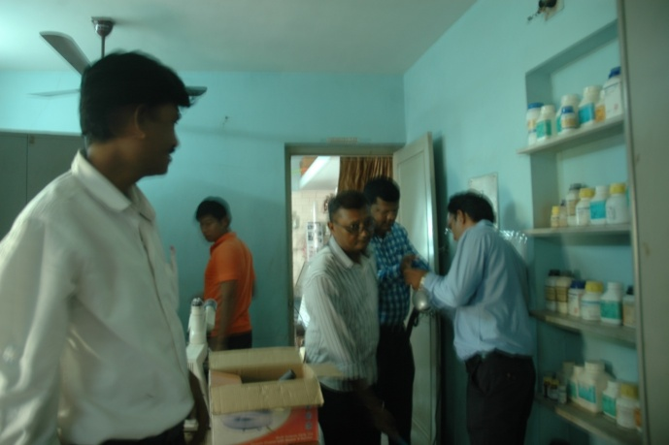
Cleaning Chemistry Laboratory

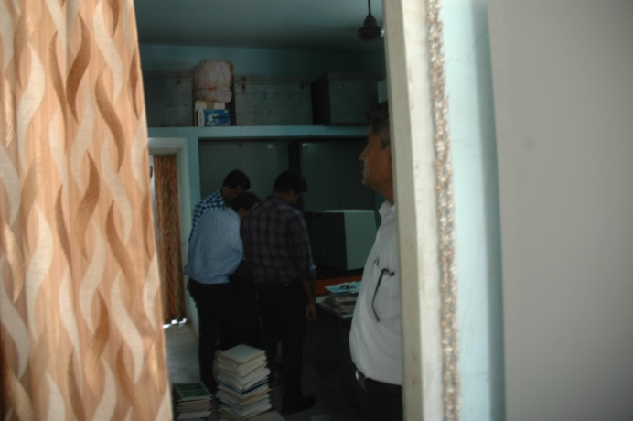
Arranging library books
Activity at ICAR-CIFRI, Guwahati:-
Cleanliness activities performed by the staff of ICAR-CIFRI Regional Centre, Guwahati during the month of April 2018 are shown in the photographs below. During the month, the staff cleaned up preparatory room, laboratories, sitting chambers, common corridor space of 4th floor and right wing of front block (4th floor).
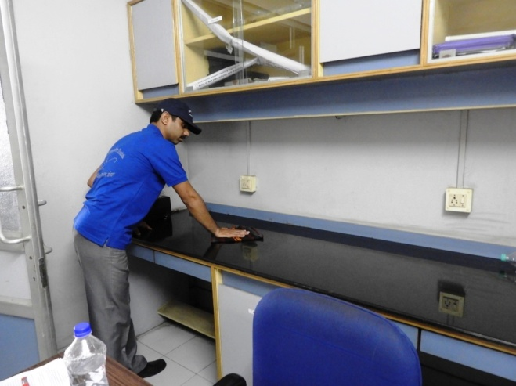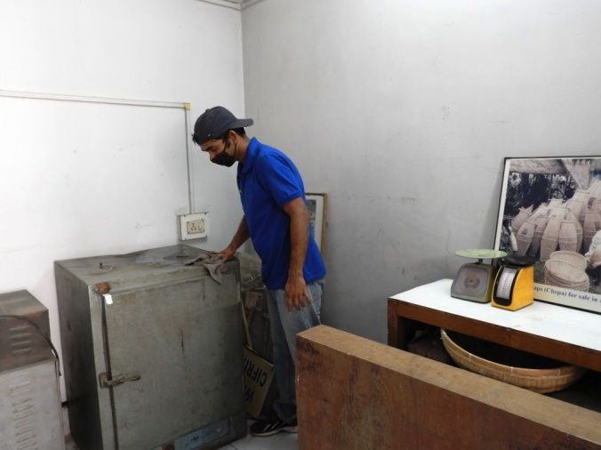
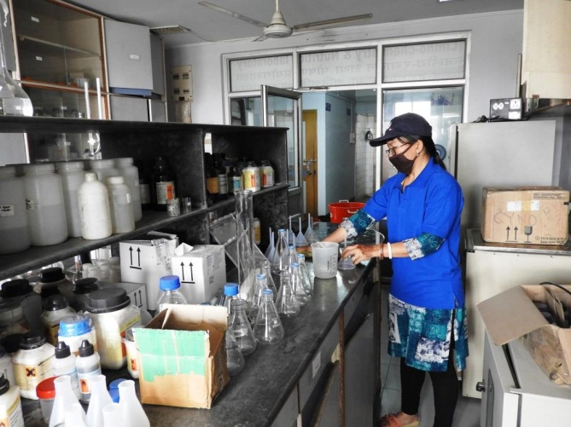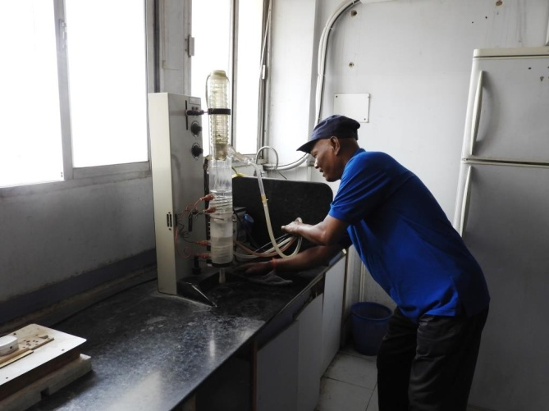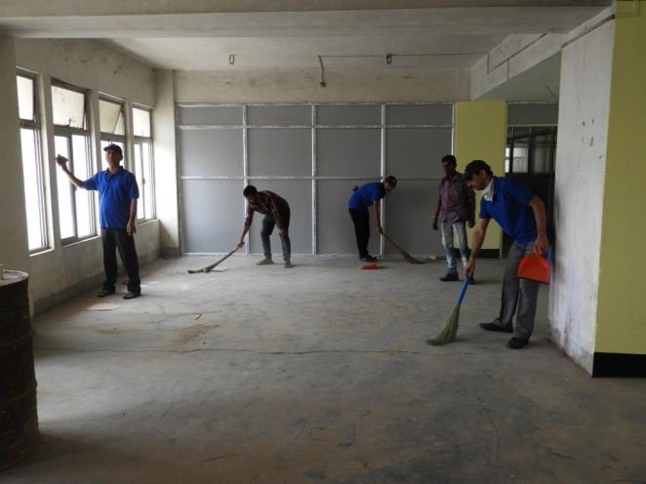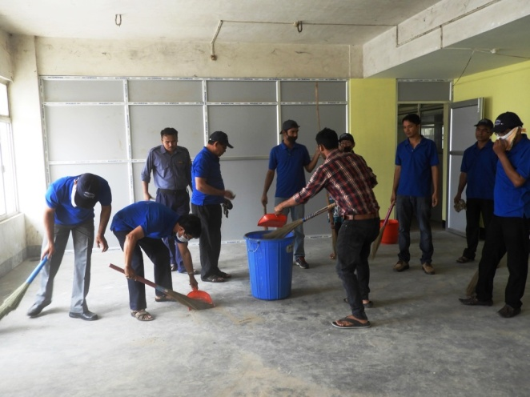
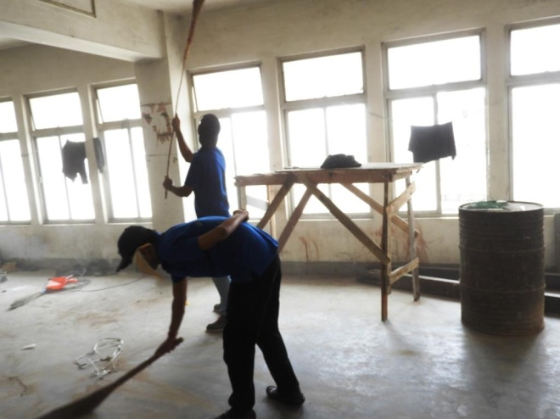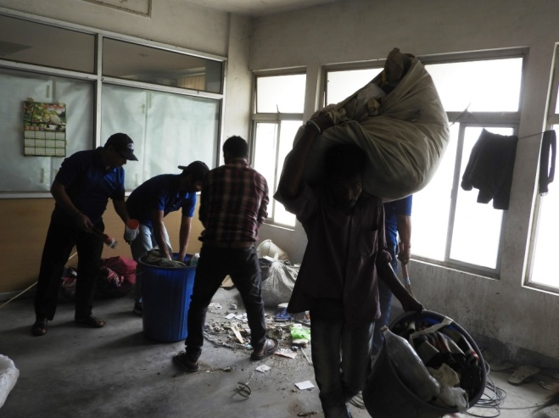
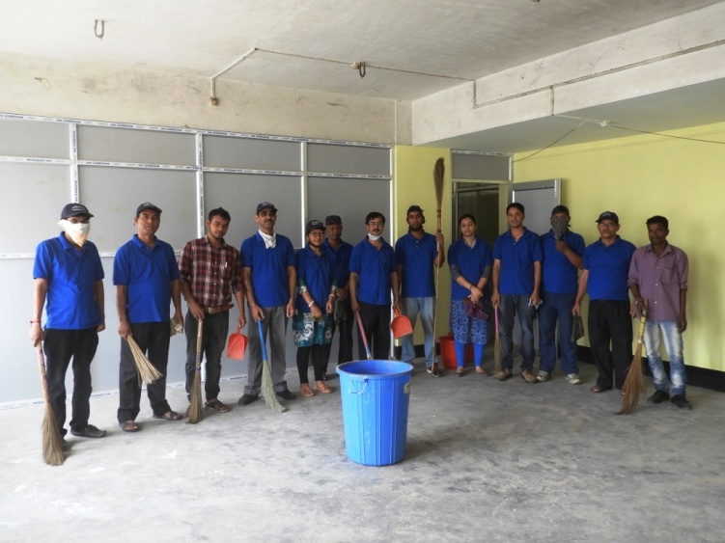
Photos. Staff of ICAR-CIFRI Regional Centre, Guwahati cleaned up preparatory room, laboratories, sitting chambers, common corridor space of 4th floor and right wing of front block (4th floor).
-----------------x-----------------

